1. What have been accomplished this past period by you?  Please give a detailed discussion accompanied with drawings, photos, videos, etc.

This past week we have been doing the same work, we were looking for the materials needed and completing the order for purchasing the materials. We got the list approved by building manager Charles “Perry” Weinthal. In order to get the materials list, we had to redesign our project in order to make it more compact and smaller, which we all collaborated on. I found a small IR sensor and nano LEDs for the design, while Greco for example got the battery and focused on reducing the microcontroller’s size.

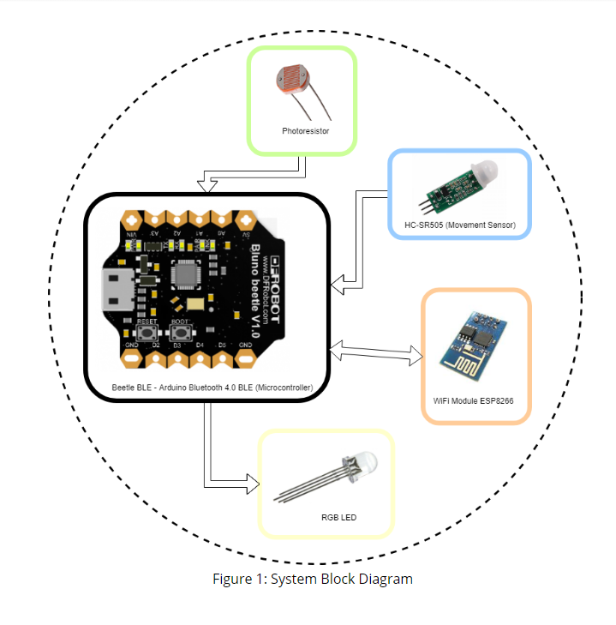

1. What will be done by you in the coming module?

I am planning on starting to do a small 3d design with a CAD program, if not, a PCB design. We will also be getting the circuitry figured out as soon as possible. I will discuss this with the team later this week.